**PRACTICAL.NO:-9**

**PYTHON PROGRAM TO DRAW BEZIER CURVES OF THE GIVEN CONTROL POINTS**

**NAME:- ROLL.NO:-**

**Q.1 B0[-1,2], B1[2,4], B2[4,1] & t=0.75**

**from numpy import\***

**from matplotlib.pyplot import\***

**from bezier import\***

**from seaborn import\***

**nodes=asfortranarray([[-1,2,4],[2,4,1]])**

**cur=Curve.from_nodes(nodes)**

**print(cur)**

**pt=cur.evaluate(0.0)**

**print(pt)**

**ax=cur.plot(num_pts=100)**

**show()**

**OUTPUT:- <Curve (degree=2, dimension=2)> [[-1.] [ 2.]]**

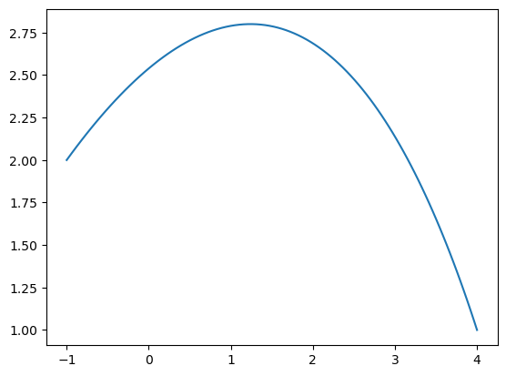

**Q.2 B0[-1,-1], B1[2,3], B2[3,3], B3[5,2] & t=0.0, 1.0 ,0.6**

**from numpy import\***

**from matplotlib.pyplot import\***

**from bezier import\***

**from seaborn import\***

**nodes=asfortranarray([[-1,2,3,5],[-1,3,3,2]])**

**cur=Curve.from_nodes(nodes)**

**print(cur)**

**print("t=0.0 \n",cur.evaluate(0.0))**

**print("t=1.0 \n",cur.evaluate(1.0))**

**print("t=0.6 \n",cur.evaluate(0.6))**

**ax=cur.plot(num_pts=100)**

**show()**

**OUTPUT:- <Curve (degree=3, dimension=2)> t=0.0 [[-1.] [-1.]] t=1.0 [[5.] [2.]] t=0.6 [[2.888] [2.528]]**

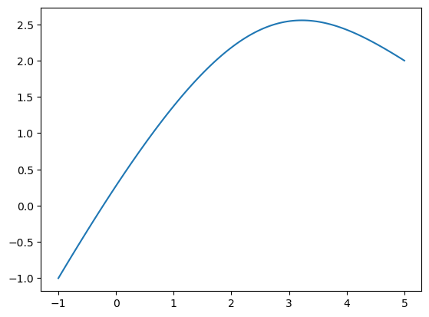

**Q.3 B0[0,2], B1[2,3], B2[3,2], B3[2,0] & t=0.0, 0.2, 0.4, 0.6**

**from numpy import\***

**from matplotlib.pyplot import\***

**from bezier import\***

**from seaborn import\***

**nodes=asfortranarray([[0,2,3,2],[2,3,2,0]])**

**cur=Curve.from_nodes(nodes)**

**print(cur)**

**print("t=0.0 \n",cur.evaluate(0.0))**

**print("t=0.2 \n",cur.evaluate(0.2))**

**print("t=0.4 \n",cur.evaluate(0.4))**

**print("t=0.6 \n",cur.evaluate(0.6))**

**ax=cur.plot(num_pts=100)**

**show()**

**OUTPUT:- <Curve (degree=3, dimension=2)> t=0.0 [[0.] [2.]] t=0.2 [[1.072] [2.368]] t=0.4 [[1.856] [2.304]] t=0.6 [[2.304] [1.856]]**

